5G New Calling SDK
Terminal Adaptation Specification

Catalogue
1 Background Description 5
2 Chipset and Terminal Interface Description 5
2.1 Data Channel Interface 5
2.1.1 Overall Design 5
2.1.2 Interface Definition 6
2.1.3 Invocation Process 6
2.2 Screen Sharing Interface 9
2.2.1 Overall Design 9
2.2.2 Interface Definition 10
2.2.3 Invocation Process 10
2.3 ARCall Interface 11
2.3.1 Overall Design 11
2.3.2 Interface Definition 11
2.3.3 Invocation Process 12
2.4 Terminal Capacity Interface 13
2.4.1 Overall Desgin 13
2.4.2 Interface Definition 14
2.4.3 Invocation Process 14
3 Terminal Requirements 14
3.1 Service Binding Restricted to Authorized Applications 14
3.2 Terminal UI Functional Requirements 15
Appendix 1: SDK-to-Terminal APIs 16
Appendix 2: Terminal Capacity Interface Field Definitions 17
Appendix 2.1 Field Definitions for Terminal Capacity SDK Calls 17
1. Retrieval of Video Call Window Display Information (Mandatory) 17
2. AI Video Monitoring (Optional) 17
3. Retrieve Supported Languages for Real-time Translation (Optional) 17
4. Enable Real-time Translation (Optional) 17
5. Stop Real-time Translation (Optional) 18
6. Set Real-time Translation Audio Channel Audio Type (Optional) 18
7. Set New Call Availability (Optional) 18
8. Set Screen Sharing Privacy Protection Status (Optional) 18
9. Enable/Disable Background Screen Sharing (Optional) 18
10. Pause Screen Sharing (Optional) 19
Appendix 2.2 Service Callback Terminal Capacity Field Definitions 19
1. Callback of Video Call Window Display Information (Mandatory) 19
2. AI Video Detection Results (Optional) 20
3. Supported Real-Time Translation Languages (Optional) 20
4. Real-time Translation Results 20
5. Check IMS Data Channel Application List Accessibility (Optional) 20
6. Open the IMS Data Channel Application List (Optional) 20
Appendix 3: Data Channel Interface 21
Appendix 3.1 IMS Data Channel Interface 21
1. IImsDataChannel Interface 21
2. IImsDataChannelServiceController Interface 22
3. ImsDCStatus Enum 23
4. ImsDCStatus 23
Appendix 3.2 IMS Data Channel Callback Interface 24
1. IDCSendDataCallback Interface 24
2. IImsDataChannelCallback Interface 24
3. IImsDCObserver Interface 25
Appendix 3.3 DataChannelAppInfo XML Information for DC Application 25
Appendix 4: ScreenShare Interface 26
Appendix 4.1 IScreenShareHandler Interface (OEM Implementation) 26
Appendix 4.2 ScreenShare Callback Interface (Invoked by OEM) 27
1. IScreenShareStatusListener Interface 27
Appendix 5: ARCall Interface 27
Appendix 5.1 IImsARCall Interface (Chipset-side Implementation) 27
Appendix 5.2 IImsARCallListener Callback Interface (Invoked by Chipset-side) 28
Appendix 5.3 ImsARCallParams Class 28
Appendix 5.4 IImsARCall Interface (OEM Implementation) 29
Appendix 5.5 IImsARCallOEMListener Callback Interface (Invoked by OEM) 30
Appendix 6: Data Channel Terminal Capacity Interface 30
Appendix 6.1 IExpandingCapacity Interface 30
Appendix 6.2 IExpandingCapacityCallback Callback Interface 31

Release Notes
Version Number | Date | Instructions
V1.0.0 | 2025.03.06 | Based on the specifications of the China Telecom Research Institute and manufacturers' implementation status, compile this terminal adaptation specification document.
V1.0.1 | 2025.04.03 | Revise Appendix 2.
V1.0.2 | 2025.04.14 | 1. Revise Appendix 2 to add descriptions of mandatory and optional items in examples.  2. In Appendix 2.1.10, add Pause Screen Sharing interface.
V1.0.3 | 2025.04.27 | 1. Revise the interface description text in Appendix 2.2.1.  2. Revise the description text of the Terminal Capability Interface chapter.
V1.0.4 | 2025.04.29 | 1. In the "Obtain Video Window Information" field of Appendix 2.1.1, add the screen width and height information of the sharing party's device.
V1.0.5 | 2025.08.20 | 1. Add fields and their descriptions in Section 2.1.1.
V1.0.6 | 2025.08.28 | 1. Supplement Item 4 in Section 3.2 and add Item 5 in Section 3.2.  2. Add an interface for querying the terminal's SDK authorization status in Appendix 1.

- Background Description
This document is intended for communication and exchange between the 5G New Calling SDK team and chipset partners and terminal partners, culminating in the formulation of this specification document.

The following are the interface definition guidelines for the 5G New Calling Commercial SDK:

1) The 5G New Calling SDK requires an independent APK with a standalone signature.
2) Existing interface designs should be reused as much as possible, provided they meet commercial requirements.
3) Minimize the definition of program interfaces with handset manufacturers, avoid compilation dependencies, and refrain from intrusive modifications to native apps wherever possible.
4) System permissions should be requested as sparingly as possible.
- Chipset and Terminal Interface Description
The primary purpose of this section is to explain the interface invocation process and aspects related to overlays. For formal interface definitions, please consult the IDL interface specification document.
  - Data Channel Interface
    - Overall Design
The DC service is implemented by the OEM. During call setup, the SDK binds to the DC service and retrieves the IImsDataChannelServiceController object, sets up a callback to wait for the DC channel object to be returned, and then proceeds with DC channel management and data transmission.

The SDK obtains the DC service's package name, class name, and action through the overlay mechanism, as well as the operator information (mccMnc). The specific details are defined as follows:

1) Package name of the SDK: com.ct.ertclib.dc

2) Overlay field name：
<string name="ims_data_channel_service_package_name" translatable="false">xxx</string>
<string name="ims_data_channel_service_cls" translatable="false">xxx</string>
<string name="ims_data_channel_service_action" translatable="false">xxx</string>
<string name="ims_data_channel_service_mccmnc" translatable="false">xxx</string>

Supplementary note on "ims_data_channel_service_mccmnc": This field determines for which carriers the SDK will provide services. If one or multiple carriers intend to use this SDK, the mmcMnc of all these carriers must be configured. For example,
<string name="ims_data_channel_service_mccmnc" translatable="false">["460-03","460-05",
"460-11", "460-12"]</string>
indicates that the SDK only provides services for China Telecom numbers. If all carriers share a single SDK, it should be configured as:
<string name="ims_data_channel_service_mccmnc" translatable="false">["ALL"]</string>
    - Interface Definition
Please refer to "Appendix 3: Data Channel Interface".
    - Invocation Process
The interaction process for BDC and ADC (locally-initiated, remotely or network-initiated) is as follows:
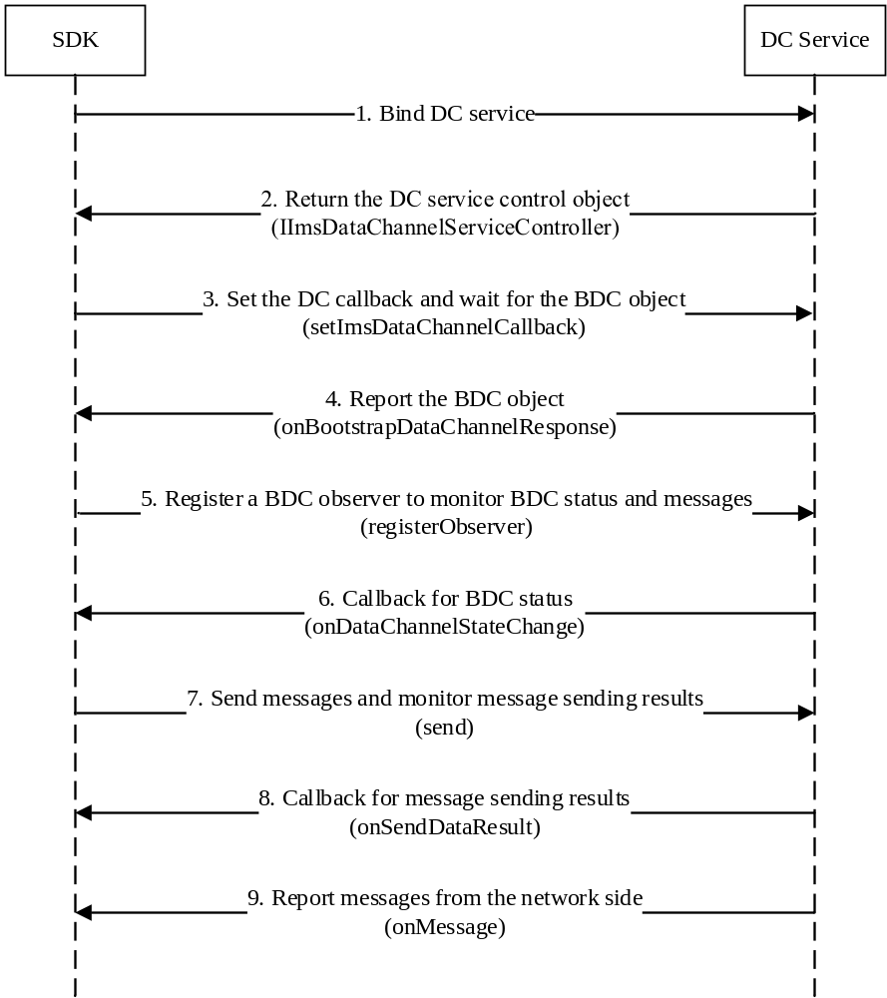
- The Interaction Process for BDC

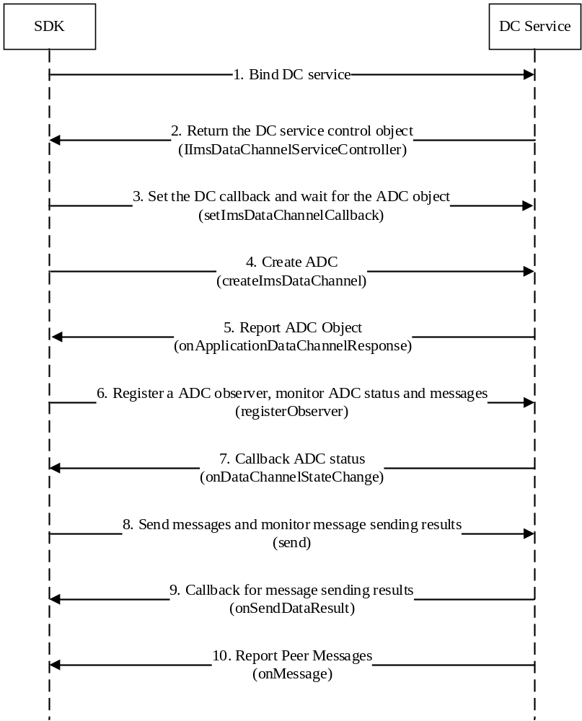
- The Interaction Process for ADC (Locally-Initiated)
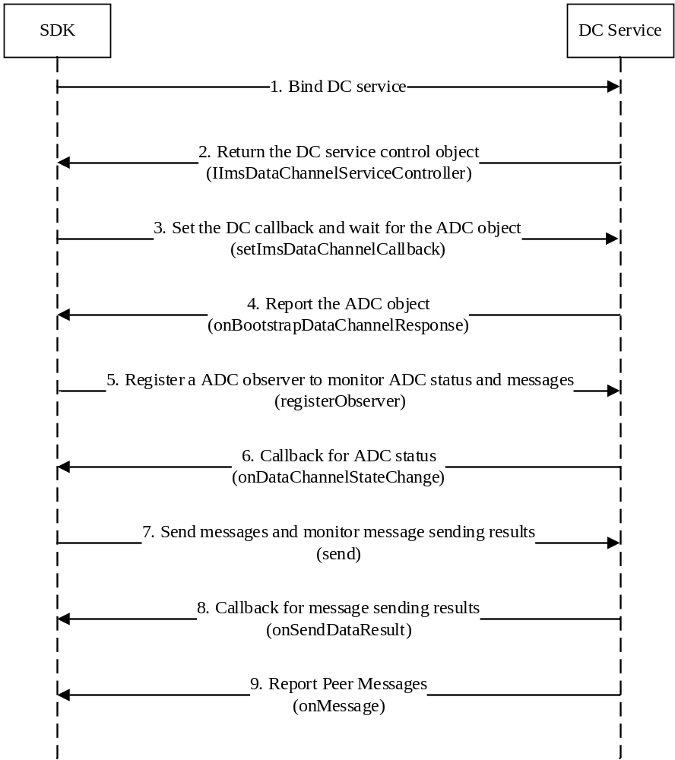
- The Interaction Process for ADC (Remotely or Network-Initiated)
  - Screen Sharing Interface
    - Overall Design
The OEM needs to provide a ScreenShareService, which can offer the New Calling SDK relevant interfaces for screen sharing functionality, including starting screen sharing, stopping screen sharing, checking whether screen sharing can be activated, and a callback interface for screen sharing activation status.

The OEM needs to configure the package name, class name, and action of ScreenShareService through the Overlay method. The XML code should be written as follows:
<string name="screenshareservice_package_name" translatable="false">xxx</string>
<string name="screenshareservice_name" translatable="false">xxx</string>
<string name="screenshareservice_action" translatable="false">xxx</string>
    - Interface Definition
For IDL interface definitions related to screen sharing, please refer to "Appendix 4: ScreenShare Interface"
    - Invocation Process
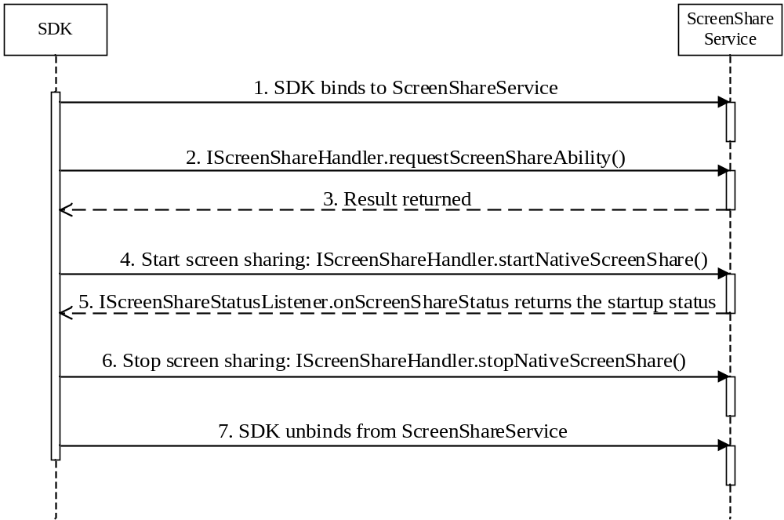
- The Screen Sharing Interaction Process
Step 1: When the call starts, the SDK binds to the ScreenShareService.
Step 2: The SDK calls requestScreenShareAbility to check if the current device can initiate screen sharing.
Step 3: The ScreenShareService returns the result.
Step 4: The SDK calls the startNativeScreenShare interface to initiate screen sharing.
Step 5: The ScreenShareService returns the screen sharing activation status to the SDK via the IScreenShareStatusListener.onScreenShareStatus callback interface.
Step 6: The SDK calls stopNativeScreenShare to stop screen sharing.
Step 7: When the call ends, the SDK unbinds from the ScreenShareService.
  - ARCall Interface
    - Overall Design
The AR feature of the 5G New Calling SDK requires the chipset side to provide the ARCallService capability and the OEM side to provide the ARCallOEMService capability. Specifically, the ARCallService from the chipset side supplies a Surface object for the IMS Data Channel, and the SDK populates it with the rendered AR video to enable ARCall. The OEM side provides the IMS Data Channel SDK with current video call window information and status details, while also callback events such as picture-in-picture toggling and front/rear camera switching to the SDK.

Both the chipset side and the OEM side should be able to customize the package name, class name, and Action through the overlay method.The XML code should be written as follows:<string name="arcall_package_name" translatable="false">xxx</string>
<string name="arcall_name" translatable="false">xxx</string>
<string name="arcall_action" translatable="false">xxx</string>
<string name="arcall_oem_name" translatable="false">xxx</string>
<string name="arcall_oem_action" translatable="false">xxx</string>
    - Interface Definition
For IDL interface definitions related to ARCall, please refer to "Appendix 5: ARCall Interface".

    - Invocation Process
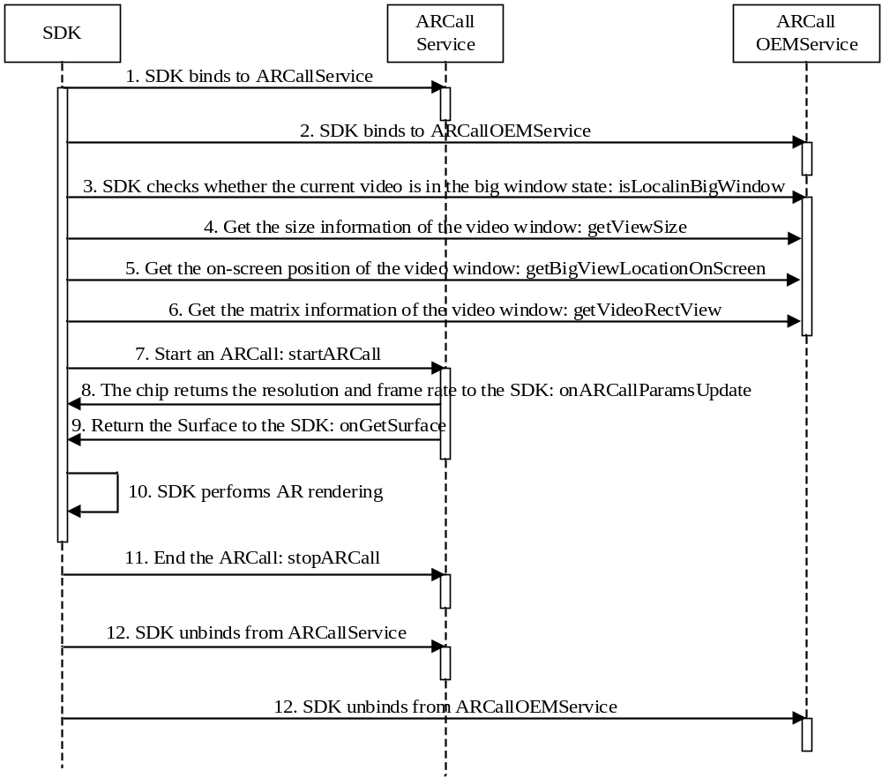
- ARCall Interaction Process
Step 1: When the call starts, the SDK binds to the ARCallService.
Step 2: The SDK binds to the ARCallOEMService.
Step 3: The SDK retrieves whether the current video is in a large window state via the isLocalingInBigWindow interface.
Step 4: The SDK retrieves the size of the current video window via the getSmallViewSize or
getBigViewSize interface.
Step 5: The SDK retrieves the on-screen position of the current video window via the getSmallViewLocationOnScreen or getBigViewLocationOnScreen interface.
Step 6: The SDK calls getVideoRectView to obtain the matrix information of the video window.
Step 7: The SDK calls startARCall to notify the chipset side to initiate the ARCall.
Step 8: The chipset side calls onARCallParamsUpdate to callback the video resolution and frame rate to the SDK.
Step 9: The chipset side calls onGetSurface to callback the Surface information to the SDK.
Step 10: The SDK begins AR rendering.
Step 11: When the user turns off the ARCall, the SDK calls stopARCall to notify the chipset side to terminate the ARCall.
Step 12: When the call ends, the SDK unbinds from the ARCallService.
Step 13: The SDK unbinds from the ARCallOEMService.

  - Terminal Capacity Interface
    - Overall Desgin
The terminal capacity service is implemented by the OEM. When a call is established, the SDK binds to the terminal capacity service, retrieves the IExpandingCapacity object, sets the callback, and interacts with the terminal capacity service.

The SDK invokes the terminal capacity service by calling the request function, and the terminal capacity service returns data to the SDK by calling the onCallback function. Both functions have only one parameter, content, which is a JSON string with the basic structure: {"module":" ", "func":" ", "data":T}. Here, `module` corresponds to the business module, `func` represents the specific operation or callback name, and `data` denotes the parameters of an operation or callback data. The terminal can extend the values of each field in content based on business requirements. For specific details, refer to the field definitions of the terminal capacity interface in Appendix 2.

The SDK obtains the package, class, and action of the terminal capacity service through the overlay method. The relevant information is specified as follows:

1) Package name of the SDK: com.ct.ertclib.dc

2) Overlay field name：
<string name="expand_capacity_service_package_name" translatable="false">xxx</string>
<string name="expand_capacity_service_cls" translatable="false">xxx</string>
<string name="expand_capacity_service_action" translatable="false">xxx</string>
    - Interface Definition
For IDL interface definitions related to Terminal Capacity interface, please refer to "Appendix 6: Data Channel Terminal Capacity Interface".

    - Invocation Process
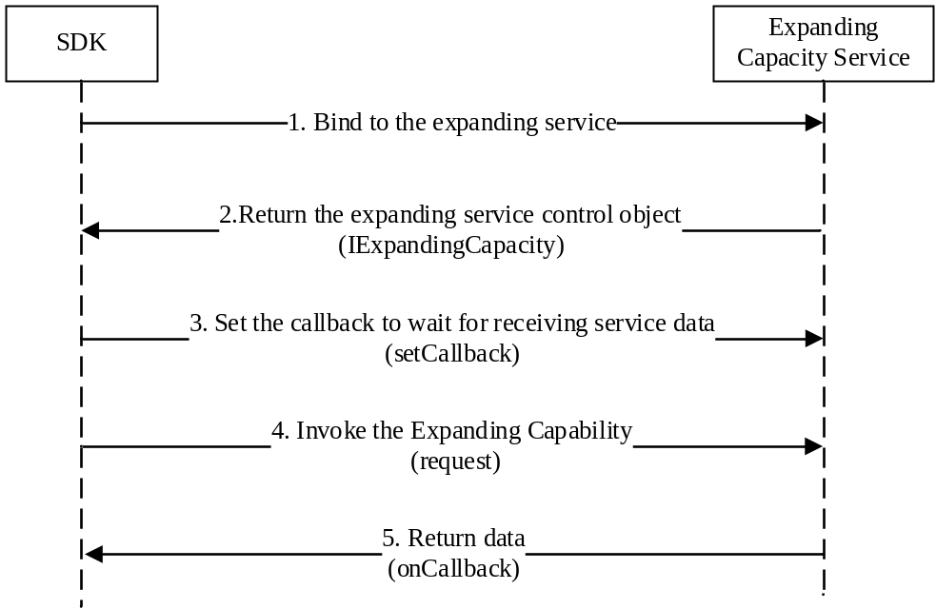
- Terminal Capacity Call Process
- Terminal Requirements
  - Service Binding Restricted to Authorized Applications
To prevent unauthorized applications from binding to the DC Service, ARCall Service, ScreenShare Service, and Terminal Capacity Service, the OEM or chipset platform must implement binding restrictions, ensuring that only applications granted permission can bind to these services.

The recommended approach involves defining necessary permissions for each service, as detailed below:
a. com.newcall.permission.BIND_DC_SERVICE, for binding to the DC Service.
b. com.newcall.permission.BIND_ARCALL_SERVICE, for binding to the two ARCall Services.
c. com.newcall.permission.BIND_SCREEN SHARE_SERVICE, for binding to the ScreenShare Service.
d. com.newcall.permission.BIND_EC_SERVICE, for binding to the Terminal Capacity Service.

To ensure the 5G New Calling SDK can adapt to all platforms with a single version, the permission names must be strictly defined as specified above if the OEM or chipset platform adopts the recommended approach.
  - Terminal UI Functional Requirements
1) To ensure the SDK logic can be triggered when users initiate call functions for the first time, terminal manufacturers must grant the following permissions by default:
a. android.permission.android.permission.CONTROL_INCALL_EXPERIENCE, to bind Call
Service.
b. android.permission.PACKAGE_USAGE_STATS, to monitor if the InCallUI is displayed in the foreground, since 5G New Calling SDK needs to be linked with it.

2) The terminal must support the SDK's ability to launch an Activity from the background in order to display pop-up windows for requesting necessary permissions from the user.

3) When the SDK applies for the floating window permission, the device must ensure that it redirects to the "5G New Calling SDK floating window permission authorization details page" instead of navigating to the application list page.

4) The device must provide a fixed entry point enabling users to independently access the SDK main interface, allowing them to view IMS Data Channel Application usage records and manage relevant authorization settings. Upon device power-on, restart, or SIM card insertion, the device must check the user's authorization status. If authorization has not been granted (i.e., when the result returns false), the device must automatically open the SDK main interface to guide the user through the authorization process. Device manufacturers must implement this functionality by calling the interfaces 1) and 2) specified in "Appendix 1: SDK-to-Terminal APIs".

5) The device should only launch the SDK for incoming or outgoing calls originating from SIM cards of operators whose mccMnc codes are supported, as specified in section 2.1.1.

Appendix 1: SDK-to-Terminal APIs
The SDK provides the following interfaces for OEM use:

1) Launch the SDK Main Interface
Required Permissions:
<uses-permission android:name="com.ct.ertclib.dc.main_permission" />
Main Activity Launch Code:
val intent = Intent("com.newcall.action.START_MAIN")
intent.flags = Intent.FLAG_ACTIVITY_NEW_TASK or Intent.FLAG_ACTIVITY_CLEAR_TOP
context.startActivity(intent)

2) Checking SDK User Authorization
Required Permissions:
<uses-permission android:name="com.ct.ertclib.dc.provider.PERMISSION" />
Query Method:
@RequiresApi(Build.VERSION_CODES.Q)
fun checkSDKPermissions(context: Context): Boolean? {
return try {
val bundle = Bundle()
val result = context.contentResolver.call("com.ct.ertclib.dc.provider",
"checkSDKPermissions", null, bundle)
result?.getBoolean("hasAllPermissions")
} catch (e: Exception) {
null
}
}

Appendix 2: Terminal Capacity Interface Field Definitions

Appendix 2.1 Field Definitions for Terminal Capacity SDK Calls
The SDK invokes the request function of IExpandingCapacity and passes the corresponding data
parameter to the DC Terminal Capacity Service as needed.

1. Retrieval of Video Call Window Display Information (Mandatory)
The SDK retrieves information such as the position, size, and orientation of the current video call display window on the mobile device. The results are returned via the terminal capacity callback interface. The parameter shareDeviceWidth represents the screen width of the screen-sharing side device, and shareDeviceHeight represents the screen height of the screen-sharing side device. These two pieces of information facilitate the terminal in calculating the video coordinates viewed by the receiving side. The terminal may choose to utilize these parameters based on their specific requirements.
{"module":"NewCallSDK","func":"getVideoShowInfo","data":{"shareDeviceWidth":"360",
"shareDeviceHeight":"1080"}}

2. AI Video Monitoring (Optional)
During video calls, the SDK requests to detect whether the current video content is AI-generated.
{"module":"AIVideo","func":"detect","data":{}}

3. Retrieve Supported Languages for Real-time Translation (Optional)
Obtain the list of optional languages supported for real-time translation on the device.
{"module":"Translate","func":"languageList","data":{}}

4. Enable Real-time Translation (Optional)
Request the device to start real-time translation. The parameter `meTo` is defined as translating my speech to English, and the parameter `otherTo` is defined as translating the remote party's speech to Chinese.
{"module":"Translate","func":"start","data":{"meTo":"English","otherTo":"Chinese"}}
- Stop Real-time Translation (Optional)
Request the device to stop real-time translation.
{"module":"Translate","func":"stop","data":{}}
- Set Real-time Translation Audio Channel Audio Type (Optional)
Whether the audio sent from the local device to the audio channel is the original or synthesized sound, type: 0 for Mixed, 1 for Original audio, 2 for Synthesized audio.
{"module":"Translate","func":"voice","data":{"type":"1"}}
- Set New Call Availability (Optional)
Set whether the IMS Data Channel Application list page can be expanded. When the IMS Data Channel Application list is expandable, the SDK will initiate the call automatically, or it will be triggered when the device invokes the query interface in Appendix 2.2 to check whether the IMS Data Channel Application can be opened.
{"module":"NewCallSDK","func":"setExpandEnable","data":{"isEnable":true}}
- Set Screen Sharing Privacy Protection Status (Optional)
The SDK sets whether to enable the screen sharing privacy protection function, which can blur sensitive data such as SMS verification codes. It carries the parameter isEnable: `true` indicates enabling privacy mode, while `false` indicates disabling privacy mode.
{"module":"ScreenShare","func":"setScreenSharePrivacyMode","data":{"isEnable":true}}
- Enable/Disable Background Screen Sharing (Optional)
During screen sharing, the SDK enables the background screen sharing function, allowing the sharer to grant access exclusively to the currently displayed application for the viewer. The viewer cannot view interfaces of other applications. When the sharer switches to another application on their screen, the viewer will still only see the initially shared application interface and cannot view the switched application interface. The parameter isEnable is included: `true` indicates enabling background sharing, while `false` indicates disabling background sharing.
{"module":"ScreenShare","func":"startBackgroundShare","data":{"isEnable":true}}
- Pause Screen Sharing (Optional)
During screen sharing, the SDK can pause the screen sharing function through this interface. When paused, the viewer is unable to see the sharer's screen. The parameter isPause is carried: `true` indicates pausing screen sharing, while `false` indicates resuming screen sharing.
{"module":"ScreenShare","func":"pauseScreenShare","data":{"isPause":true}}

Appendix 2.2 Service Callback Terminal Capacity Field Definitions
The DC Terminal Capacity Service invokes the `onCallback` function of IExpandingCapacity-Callback and passes the corresponding data parameter to the SDK based on specific business requirements.
- Callback of Video Call Window Display Information (Mandatory)

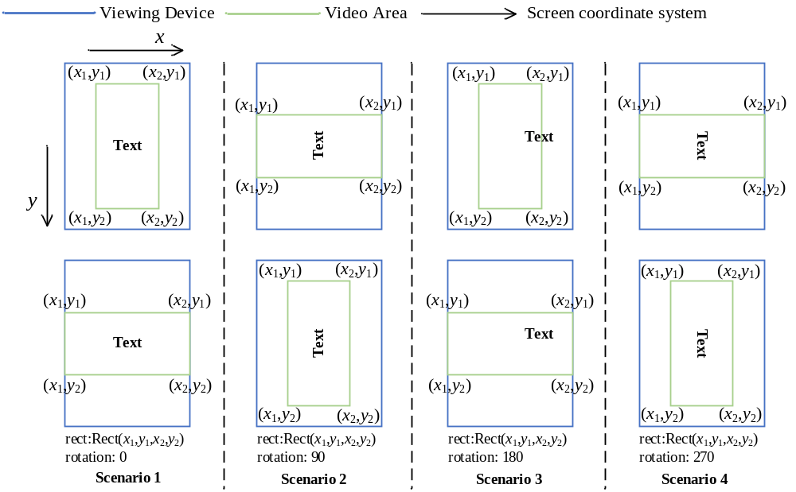
Diagram of Rect and Rotation Values under Different Device Rotation States
The OEM transmits video call window information to the SDK through the callback interface. The `rect` parameter represents the coordinate information of the video window within the entire device, while `rotation` indicates the counterclockwise rotation angle of the video window relative to the device's vertical orientation. The figure below illustrates the expected `rect` and `rotation` in-
formation under different scenarios.
{"module":"NewCallSDK","func":"onVideoShowInfo","data":{"rect":"0,0,360,1080","rotation":"0"}}

- AI Video Detection Results (Optional)
During video calls, the detection result of whether the current video content is AI-generated is returned to the SDK.
{"module":"AIVideo","func":"detectCallback","data":{"isAI":true}}
- Supported Real-Time Translation Languages (Optional)
Optional languages for real-time translation.
{"module":"Translate","func":"languageListCallback","data":{"list":["Chinese","English"]}}
- Real-time Translation Results
The device's real-time translation text results.
{"module":"Translate","func":"translateResultCallback","data":{"Original":"你好","Translate":
"hello","type":1/2}} // 1. Our Side 2. Remote Side
- Check IMS Data Channel Application List Accessibility (Optional)
Query whether the IMS Data Channel Application list interface can be opened. The result will be returned via the "Set New Call Availability" function in Appendix 2.1.
{"module":"NewCallSDK","func":"queryExpandEnable","data":{}}。
- Open the IMS Data Channel Application List (Optional)
Expand the IMS Data Channel Application list page.
{"module":"NewCallSDK","func":"expand","data":{}}

Appendix 3: Data Channel Interface

Appendix 3.1 IMS Data Channel Interface
- IImsDataChannel Interface
Provide a Data Channel capability calling interface to SDK.
interface IImsDataChannel {
void registerObserver(in IImsDCObserver l);
void unregisterObserver();
boolean send(in byte[] data, int length, in IDCSendDataCallback l);
void close();
String getDcLabel();
String getSubProtocol();
long bufferedAmount();
int getDCType();
ImsDCStatus getState();
String getTelecomCallId();
String getStreamId();
String getPhoneNumber();
}

(1) Registration of an IMS Data Channel observer.
void registerObserver(in IImsDCObserver l);

(2) Unregistration of an IMS Data Channel observer.
void unregisterObserver();

(3) Send byte data of a specified length with the IDCSendDataCallback.
boolean send(in byte[] data, int length, in IDCSendDataCallback l);

(4) Close IMS Data Channel.
void close();

(5) Get the label of the IMS Data Channel.
String getDcLabel();

(6) Get the IMS Data Channel sub-protocol.
String getSubProtocol();

(7) Get the size of the cache, which indicates the remaining cache available for the application to send data.
long bufferedAmount();

(8) Get the type of IMS Data Channel.
int getDCType();

(9) Get the status of the IMS Data Channel.
ImsDCStatus getState();

(10) Get the call ID of the data channel.
String getTelecomCallId();

(11) Get the stream ID of the data channel.
String getStreamId();

(12) Get the mobile phone number.
String getPhoneNumber();

- IImsDataChannelServiceController Interface
Provide a Data Channel creation capability calling interface to SDK.
interface IImsDataChannelServiceController {
void createImsDataChannel(in String [] dcLabels, String appInfoXml, int slotId,
String telecomCallId, String remotePhoneNumber);
void setImsDataChannelCallback(in IImsDataChannelCallback l, int slotId,
String telecomCallId);
void setModemCallId(int slotId, int modemCallId, String telecomCallId); // 可选
}
(1) Create Application Data Channel
Requires the dcLabels list, slotId, telecomCallId, and appInfoXml.
void createImsDataChannel(in String [] dcLabels, String appInfoXml, int slotId,
String telecomCallId, String remotePhoneNumber);

(2) Set the callback method for the Data Channel, including: callback method, slotId, and callback telecomCallId.
void setImsDataChannelCallback(in IImsDataChannelCallback l, int slotId,
String telecomCallId);

(3) For Qualcomm chipsets, the mapping of telecommCallId and modemCallId is mandatory; it is optional for other chipset vendors.
void setModemCallId(int slotId, int modemCallId, String telecomCallId)
- ImsDCStatus Enum
Provide Data Channel status information to SDK.
public enum ImsDCStatus implements Parcelable {
DC_STATE_CONNECTING,
DC_STATE_OPEN,
DC_STATE_CLOSING,
DC_STATE_CLOSED;
}

(1) Data Channel is connecting.
DC_STATE_CONNECTING

(2) Data Channel is open.
DC_STATE_OPEN

(3) Data Channel is closing.
DC_STATE_CLOSING

(4) Data Channel is closed.
DC_STATE_CLOSED
- ImsDCStatus
Parcelable ImsDCStatus

Appendix 3.2 IMS Data Channel Callback Interface

1. IDCSendDataCallback Interface
Provide a DC data transmission callback interface for the SDK.
interface IDCSendDataCallback {
void onSendDataResult(int state);
}

(1) IMS Data Channel Sending Data Callback Interface
onSendDataResult(int state)
The callback of the DC service when the send(in byte[] data, int length, in IDCSendDataCallback l) API is called.

state | Message Description
20000 | Send Success
20001 | Send Buffer Full
20002 | DC Failure/DC Disconnected
20003 | Invalid Parameters
20004 | Unknown Error

2. IImsDataChannelCallback Interface
Provide BDC and ADC callback interfaces for the SDK.
interface IImsDataChannelCallback {
void onBootstrapDataChannelResponse(in IImsDataChannel dc);
void onApplicationDataChannelResponse(in IImsDataChannel dc);
}

(1) Notifies the client that the BDC data channel has been created successfully. Parameter: Data Channel object.
void onBootstrapDataChannelResponse(in IImsDataChannel dc);

(2) Notifies the client that the ADC data channel has been created successfully. Parameter: Data Channel object.
void onApplicationDataChannelResponse(in IImsDataChannel dc);

3. IImsDCObserver Interface
Provide a DC observer for SDK to monitor data channel state changes.
interface IImsDCObserver {
void onDataChannelStateChange(in ImsDCStatus status, int errCode);
void onMessage(in byte[] data, int length);
}

(1) Callback to notify the client that the data channel state has changed. Parameter: status value. If the received status is ImsDCStatus::DC_STATE_CLOSED, the client should invoke the IImsDCManager::close() API.
void onDataChannelStateChange(in ImsDCStatus status, int errCode);

errCode | Message Description
20000 | DC not closed
20001 | Invalid parameter
20002 | Request failed
20003 | Network issue
20004 | Other errors

(2) Callback to notify the client that a message has been received.
void onMessage(in byte[] data, int length);

Appendix 3.3 DataChannelAppInfo XML Information for DC Application
In the createDataChannel API, the SDK passes the <DataChannelAppInfo> XML to request the establishment of an application data channel (DC). The request is processed and parsed along with the XML on the modem side. Please refer to the following XML example:
<DataChannelAppInfo>
<DataChannelApp appId="DcCall"><!-- Required --->
<DataChannel dcId="dcID1"><!-- Required --->
<StreamId></StreamId><!-- Required, value is empty --->
<DcLabel>local_DcCall_1_dcID1</DcLabel><!-- Required --->
<Subprotocol></Subprotocol><!-- Optional --->
<Ordered>1</Ordered><!-- Optional --->
<MaxRetr>0</MaxRetr><!-- Optional --->
<MaxTime>0</MaxTime><!-- Optional --->
<Priority></Priority><!-- Optional --->
<UseCase>1</UseCase><!—Required, 0:P2A; 1: P2P, 2:A2P --->
<AutoAcceptDcSetup>0</AutoAcceptDcSetup><!-- Optional --->
<Bandwidth>500</Bandwidth><!-- Optional --->
<QosHint>loss=0.01;latency=100</QosHint><!-- Optional --->
<Content>ctcc.webrtc-datachannel.adc</Content><!— Optional, The business identifier of the stream, such as a custom one like ctcc.webrtc-datachannel.free, can be used subsequently to differentiate between paid and free services. --->
</DataChannel>
<DataChannel dcId="dcID2">
<StreamId></StreamId>
<DcLabel>local_DcCall_1_dcID2</DcLabel>
<UseCase>0</UseCase>
</DataChannel>
</DataChannelApp>
</DataChannelAppInfo>

Appendix 4: ScreenShare Interface

Appendix 4.1 IScreenShareHandler Interface (OEM Implementation)
interface IScreenShareHandler {
void startNativeScreenShare(in IScreenShareStatusListener l);
void stopNativeScreenShare();
boolean requestNativeScreenShareAbility();
}

(1) Start screen sharing and pass the IScreenShareStatusListener callback.
void startNativeScreenShare(in IScreenShareStatusListener l);

(2) Stop screen sharing.
void stopNativeScreenShare();

(3) Check if screen sharing can be started.
boolean requestNativeScreenShareAbility();

Appendix 4.2 ScreenShare Callback Interface (Invoked by OEM)

1. IScreenShareStatusListener Interface
The SDK monitors screen sharing state changes.
public ScreenShareStatus implements Parcelable {
SUCCESS,
FAILURE;
}

(1) Screen sharing successful.
SUCCESS

(2) Screen sharing failed.
FAILURE

Appendix 5: ARCall Interface

Appendix 5.1 IImsARCall Interface (Chipset-side Implementation)
IDL interface for ARCall and chipset-side interaction.
interface IImsARCall {
void setARCallListener(in IImsARCallListener listener);
boolean isARAvailable();
void startARCall();
void stopARCall();
void releaseSurface();
}

(1) Set a listener for the 5G New Calling SDK to the OS side.
void setARCallListener(in IImsARCallListener listener);

(2) Check whether the device supports AR functionality.
boolean isARAvailable();

(3) Start an ARCall.
void startARCall();

(4) Stop the ARCall.
void stopARCall();

(5) Release the Surface.
void releaseSurface();

Appendix 5.2 IImsARCallListener Callback Interface (Invoked by Chipset-side)
IDL callback interface for ARCall implemented by the chipset side.
interface IImsARCallListener {
void onGetSurface(in Surface surface, in int state);
boolean onGetSurfacePreview(in Surface surface);
void onARCallParamsUpdate(in ImsARCallParams params);
}

(1) The chipset passes the Surface for video encoding to the 5G New Calling SDK.
void onGetSurface(in Surface surface, in int state);

(2) The chipset passes the Surface for IncallUI preview to the 5G New Calling SDK.
boolean onGetSurfacePreview(in Surface surface);

(3) The chipset notifies the New Calling SDK of parameter updates.
void onARCallParamsUpdate(in ImsARCallParams params);

Appendix 5.3 ImsARCallParams Class
Class for ARCall video display information, containing video width, height, and frame rate details.
public class ImsARCallParams implements Parcelable {
public int width;// Video Width
public int height;// Video Width
public int fps;// Video Frame Rate
}

Appendix 5.4 IImsARCall Interface (OEM Implementation)
IDL interface for ARCall and OEM interaction.
interface IImsARCallOEM {
void setARCallOEMListener(in IImsARCallOEMListener listener);
int getCameraId();
boolean isLocalInBigWindow();
void switchWindow();
void getBigViewSize(out int[] outSize);
void getBigLocationOnScreen(out int[] outLocation);
void getSmallViewSize(out int[] outSize);
void getSmallViewOnScreen(out int[] outLocation);
void getVideoRectInView(out Rect rect);
}

(1) Set a listener for the 5G New Calling SDK to the OEM side.
void setARCallOEMListener(in IImsARCallOEMListener listener);

(2) Get the currently used camera ID.
int getCameraId();

(3) Check whether the local preview window is the large window.
boolean isLocalInBigWindow();

(4) Notify the device to switch the preview view size (between large and small windows).
void switchWindow();

(5) Get the dimensions of the large window in pixels.
void getBigViewSize(out int[] outSize);

(6) Get the on-screen position of the large window (the y coordinate includes the height of the status bar), in pixels.
void getBigLocationOnScreen(out int[] outLocation);

(7) Get the dimensions of the small window in pixels.
void getSmallViewSize(out int[] outSize);

(8) Get the on-screen position of the small window in pixels.
void getSmallViewOnScreen(out int[] outLocation);

(9) Get the area of the video within the preview view.
void getVideoRectInView(out Rect rect);

Appendix 5.5 IImsARCallOEMListener Callback Interface (Invoked by OEM)
IDL callback interface for ARCall implemented by the OEM side.
interface IImsARCallOEMListener {
void onCameraSwitched(in int cameraId);
boolean onCameraClosed();
void onWindowSwitched(in int params);
}

(1) The OS notifies the Call SDK that the camera has been switched.
void onCameraSwitched(in int cameraId);

(2) The OS notifies the Call SDK of a camera closing event.
boolean onCameraClosed();

(3) The OS notifies the Call SDK that the window size has been switched.
void onWindowSwitched(in int params);

Appendix 6: Data Channel Terminal Capacity Interface

Appendix 6.1 IExpandingCapacity Interface
Provide an interface for the SDK to invoke the terminal's DC extension capabilities along with setting up callbacks.
interface IExpadningCapacity {
void request(String content);
void setCallback(in IExpandingCapacityCallback l);
}

The SDK calls the terminal's DC Capacity.
void request(String content);

The SDK sets the DC Terminal Capacity callback interface.
void setCallback(in IExpandingCapacityCallback l);

Appendix 6.2 IExpandingCapacityCallback Callback Interface
The SDK monitors the Terminal Capacity interface callbacks and receives the callback information passed by the OEM.
interface IExpandingCapacityCallback{
void onCallback(String content);
}

(1) The terminal callback function passes the result back to the SDK.
void onCallback(String content);

